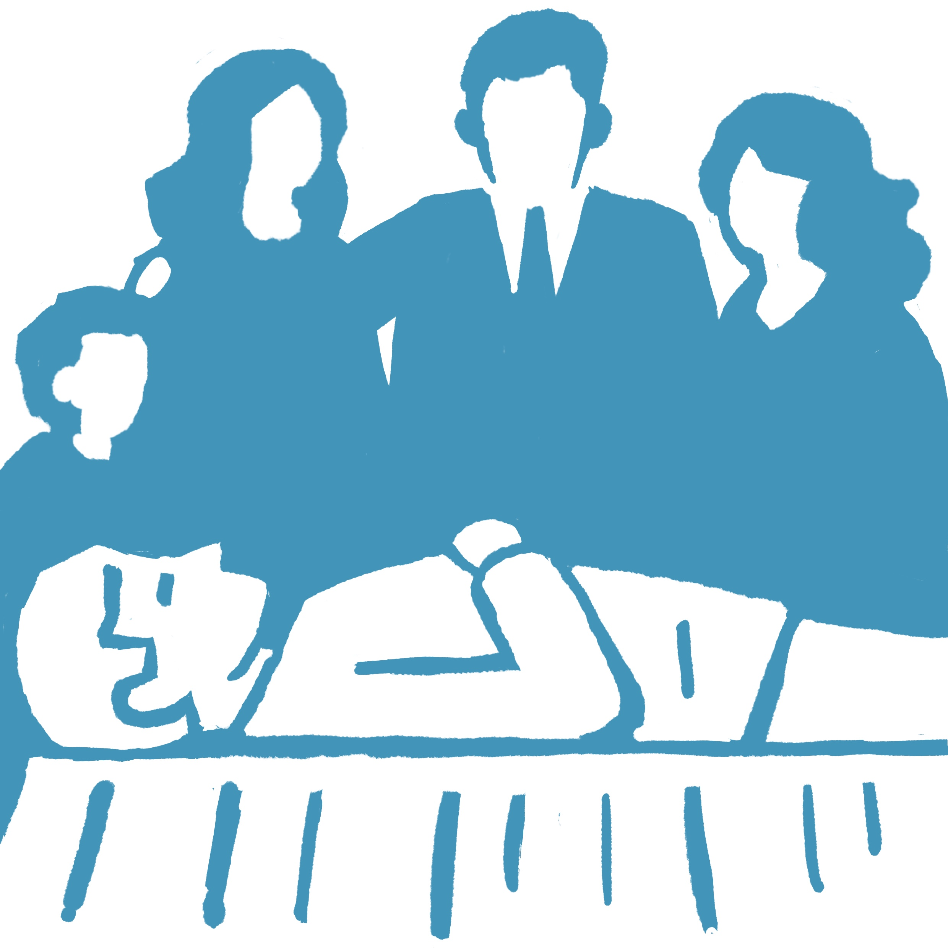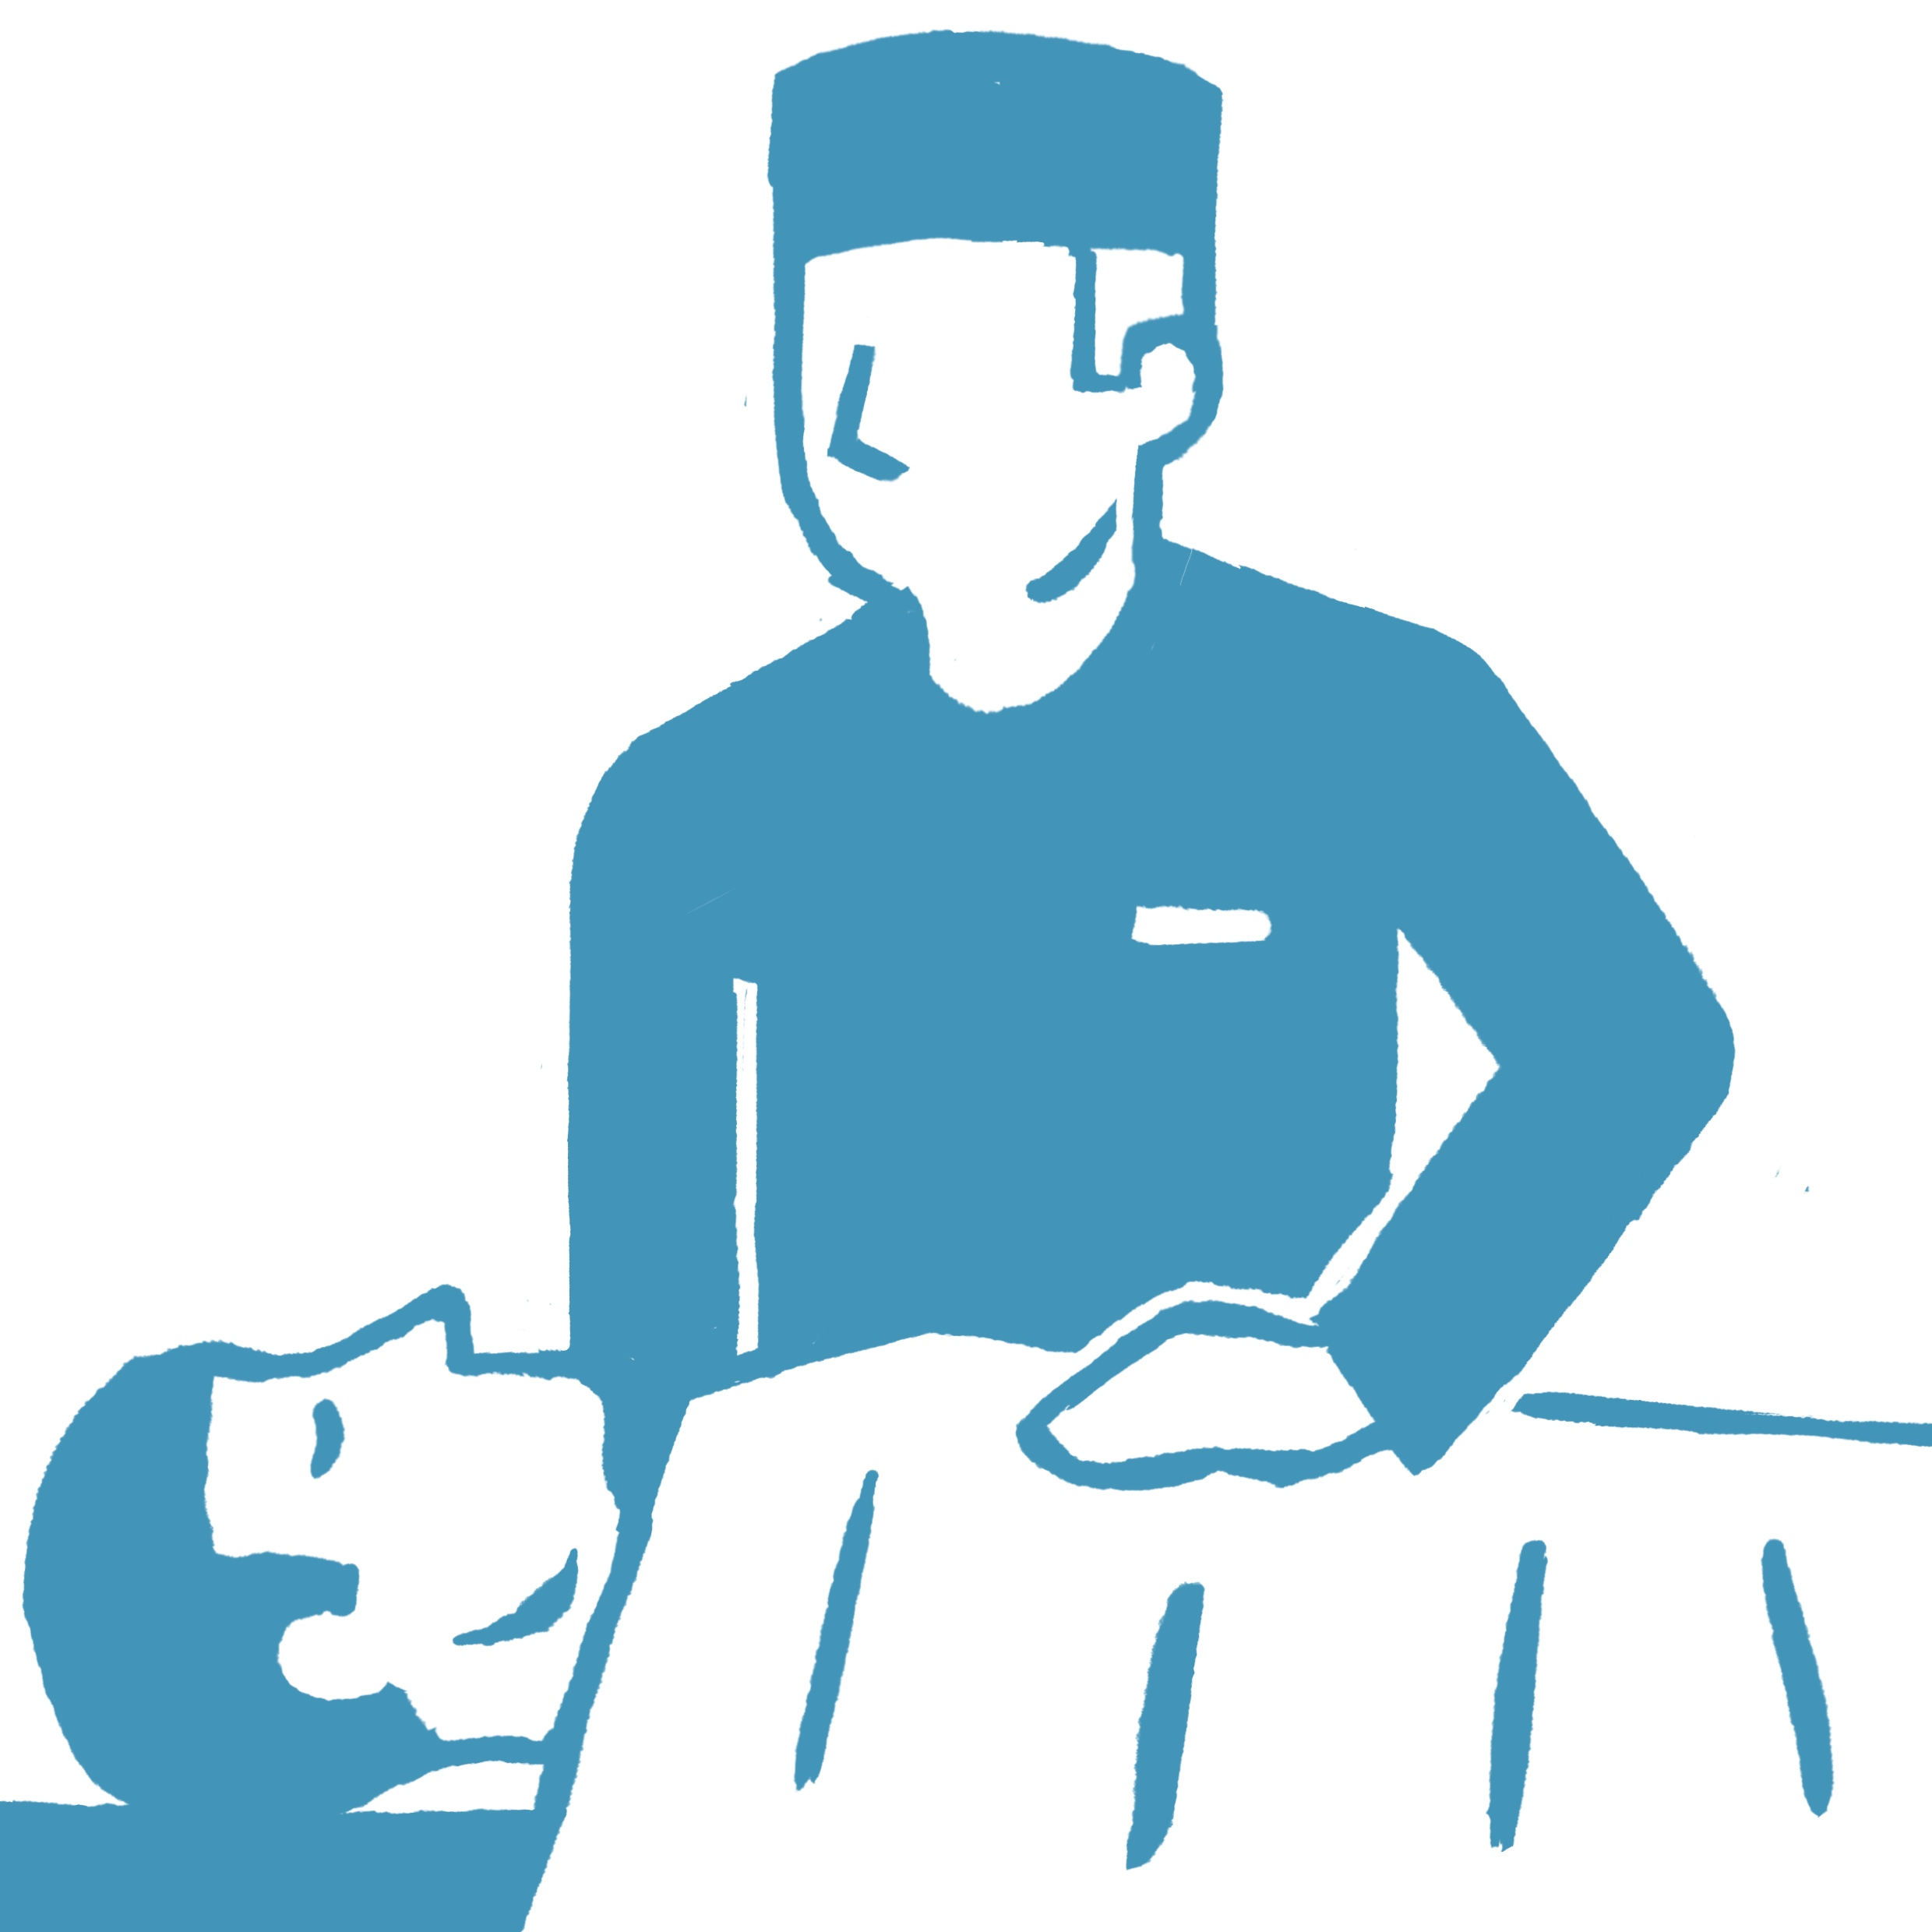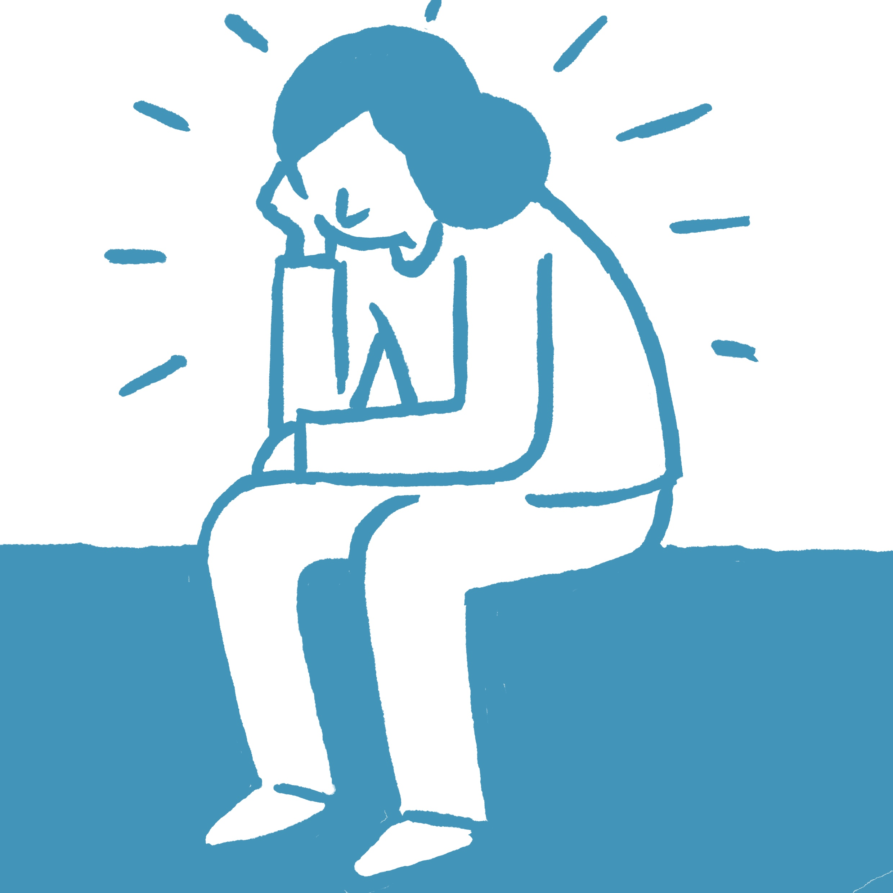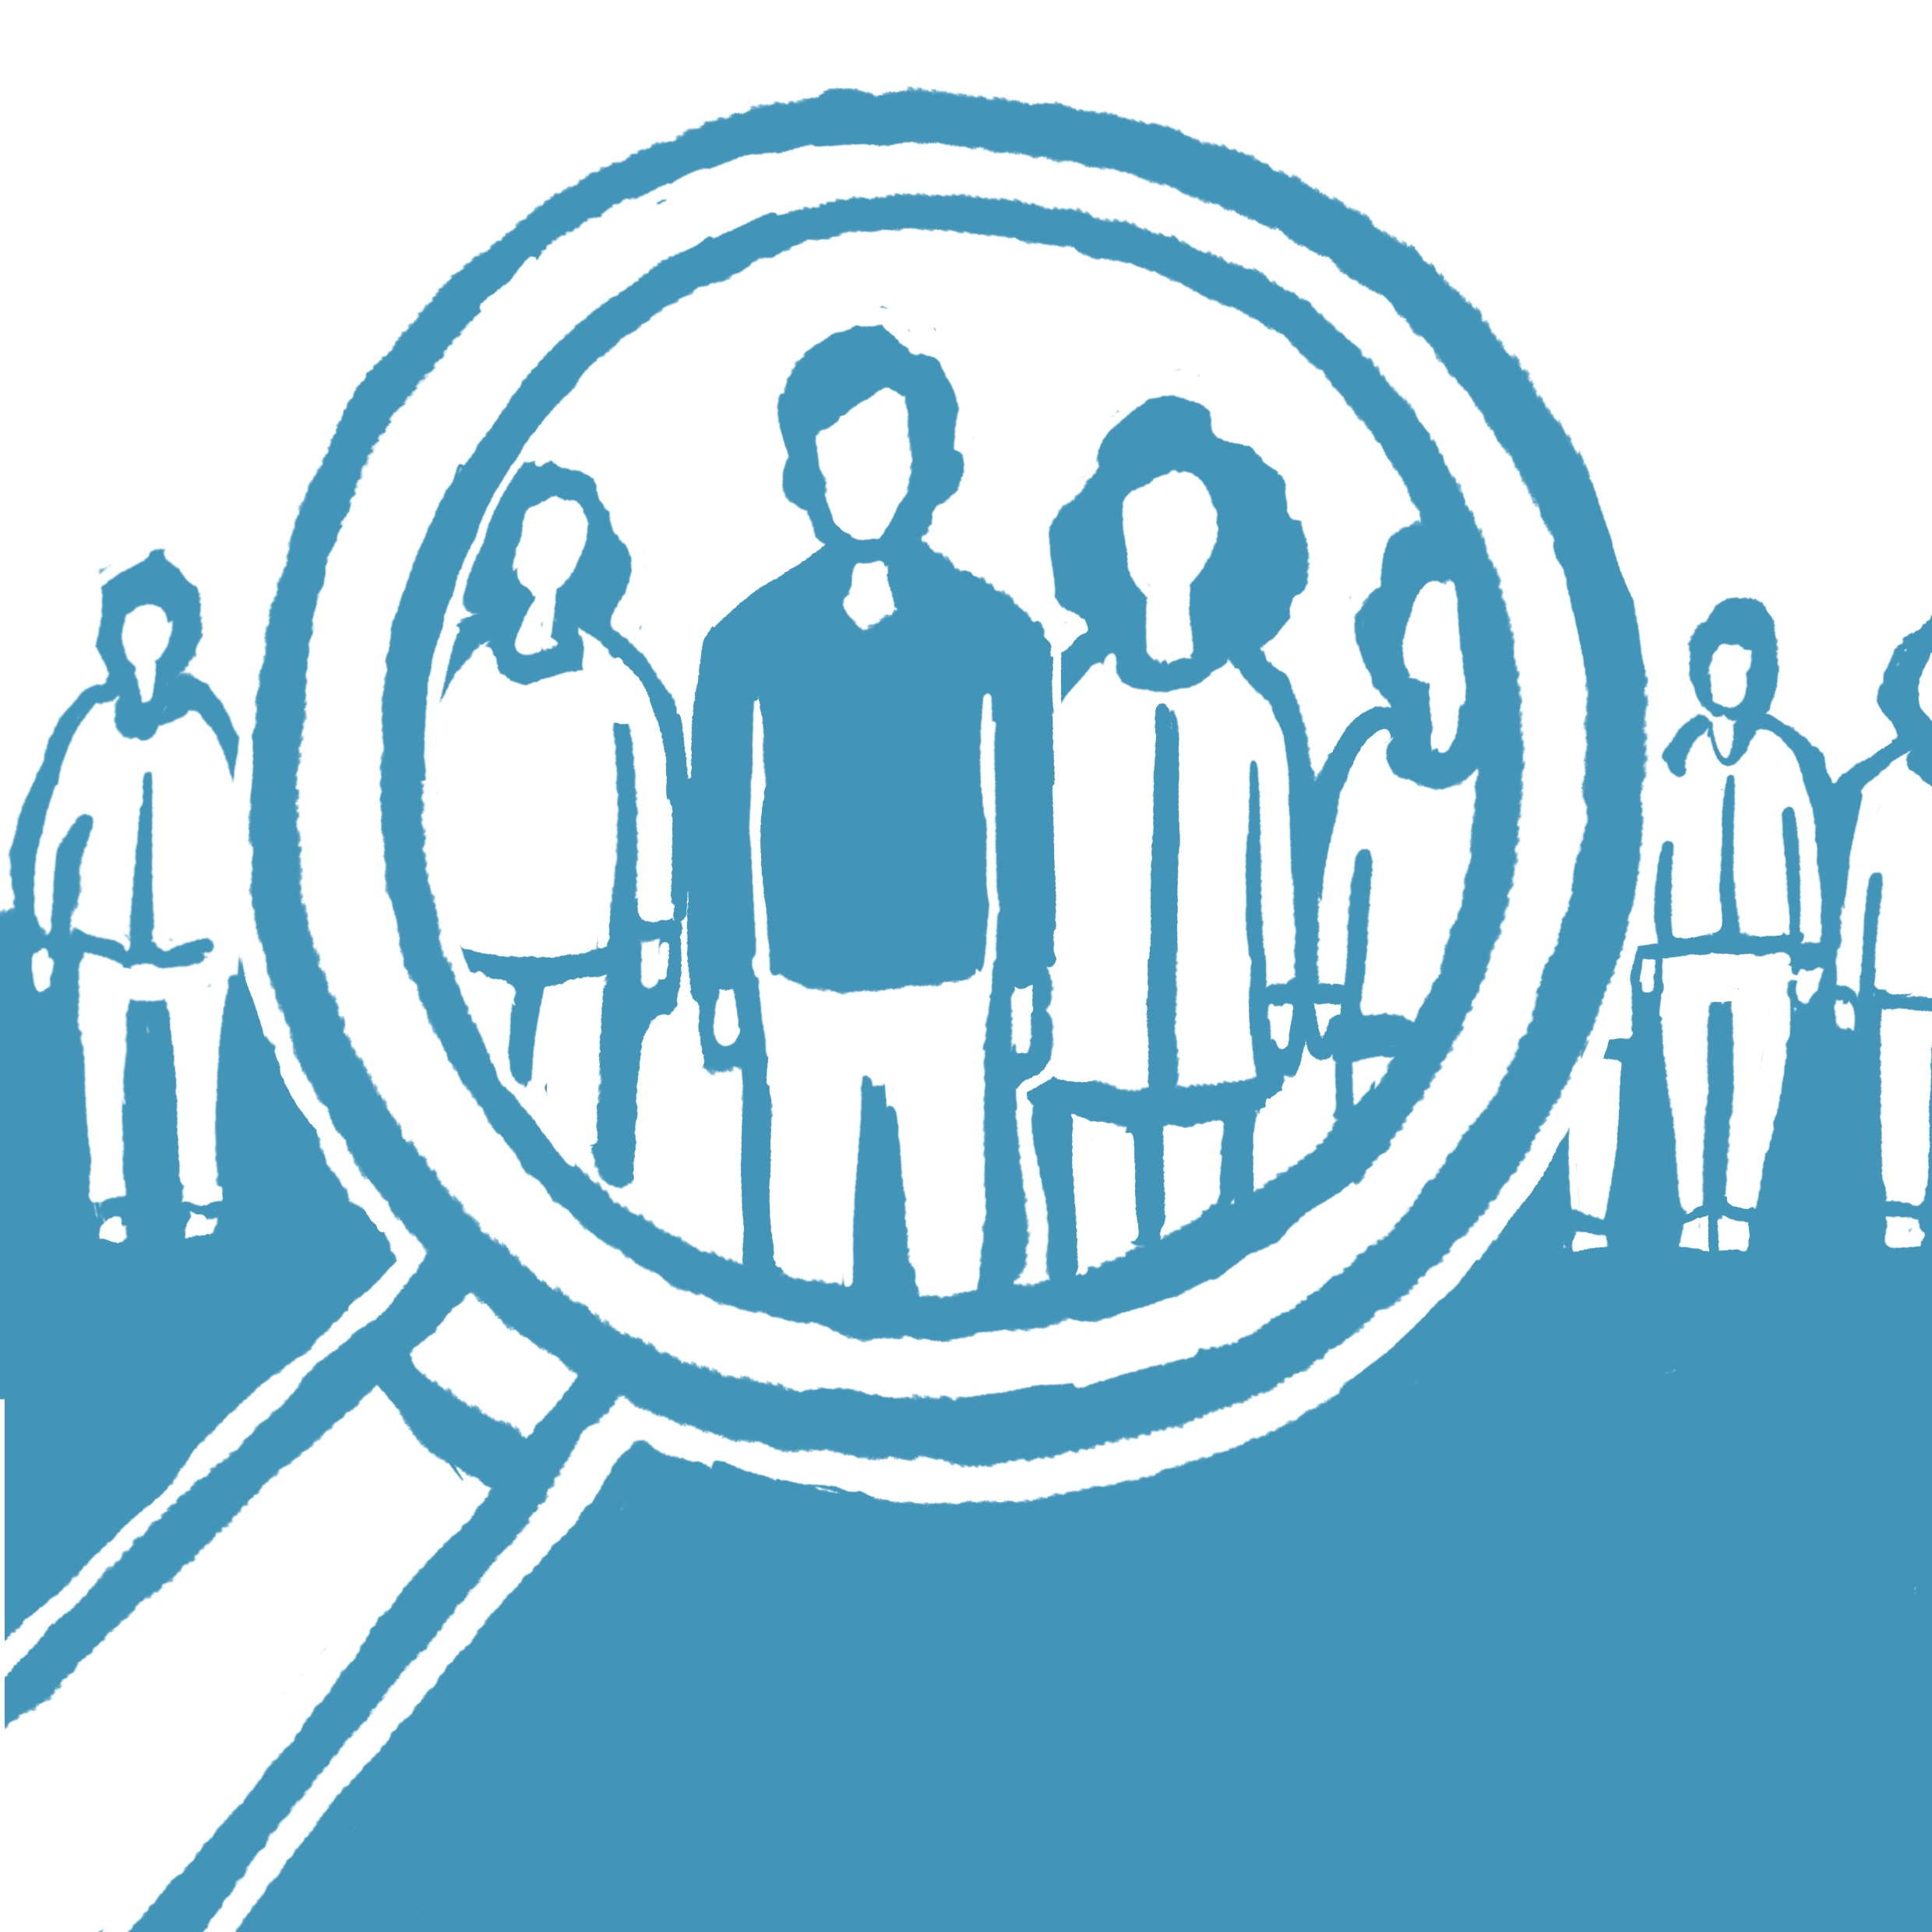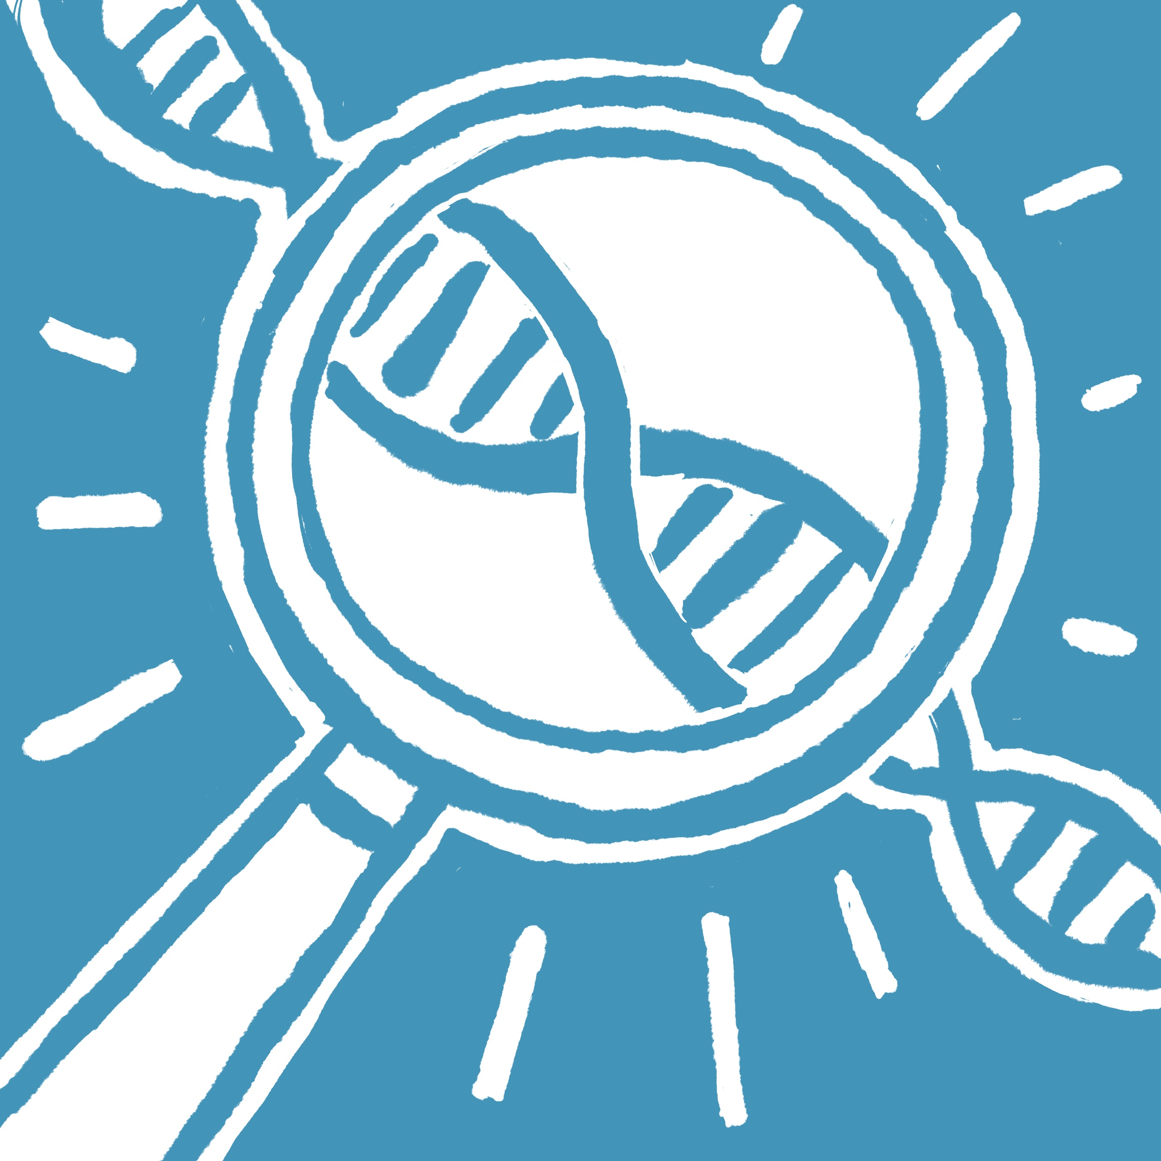

Inherited heart conditions can be passed on through families. Some people with an inherited heart condition have no symptoms, and often the first sign there’s something wrong is when someone dies suddenly, with no obvious cause. Your family member may be the only person in the family to develop the condition.

However, it is recommended that their immediate family members (parents, siblings, children) are seen by an expert centre specialised on rare heart diseases to see if they have the same condition. This way, you and your family can be well advised, and protected in case of a genetic disease. Each family member will do this at their own pace.

**Why is it important to have medical examinations for the whole family?**

**Why is it so important to perform post-mortem examination and decide quickly?**

In many cases (about 40%), sudden cardiac death in children and young adults under the age of 50 has a familial, i.e. genetic, cause - the younger the more often. For this reason, experts strongly recommend that an autopsy and a genetic examination of the deceased young person be arranged with the goal to prevent death in other family members at risk. Indeed, the identification of a precise cause or disease will be of major importance to adjust the management of the family (e.g. the precise examinations to be performed and the optimal decision for therapeutics).

If the autopsy is not possible, or a family member denies it, please agree that blood or tissue from the deceased one is secured and saved so that it can be examined at a later date. This makes sure that a genetic testing of the DNA may be performed if you decide it is the right time to do so.

**Sudden unexpected death of a loved one - what now**

Although you may feel completely overwhelmed and don't want to deal with these issues right now because of the shock and the deep grief, it is extremely important to consider a few aspects if you like to get an answer as to the “why”? In the short time between the death of your beloved one and the funeral you will need to make important decisions which may have enormous implications for your family.

Please accept our sincere condolences for the loss of your loved one.

Your family member has died - just like that, from one minute to the next, without any warning signs. Your pain and the shock are unbelievable! Now the question is pounding in your head: Why? How could this happen? My family member was so young! He or she seemed to be completely healthy!

**You may be offered a post-mortem examination**  
We strongly recommend agreeing to it, even if you don't feel like it right now – the doctors want to help you and try to uncover the cause of death and give you answers

OR

**The autopsy may have been ordered by a coroner**  
In this case you don´t have the possibility to deny the autopsy. Even if this causes you additional pain, you can be sure that everything will be done to find out about the reasons for the death of your loved one and give you an answer to the “why?”

You will find a way to say goodbye to your beloved family member in a way that is good for you, despite the autopsy. After the examinations, the body is washed, and the deceased is dressed. To find out about the cause of the death can help you cope better with your deep grief.

???

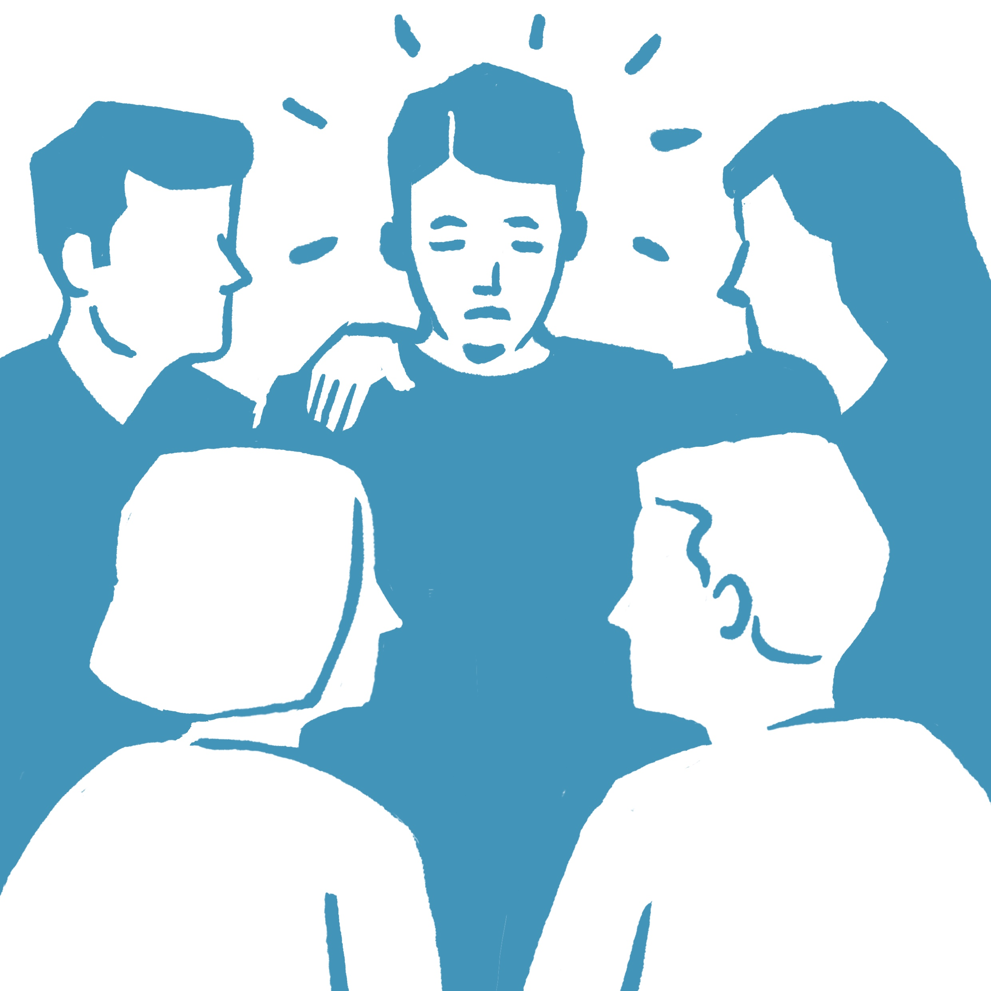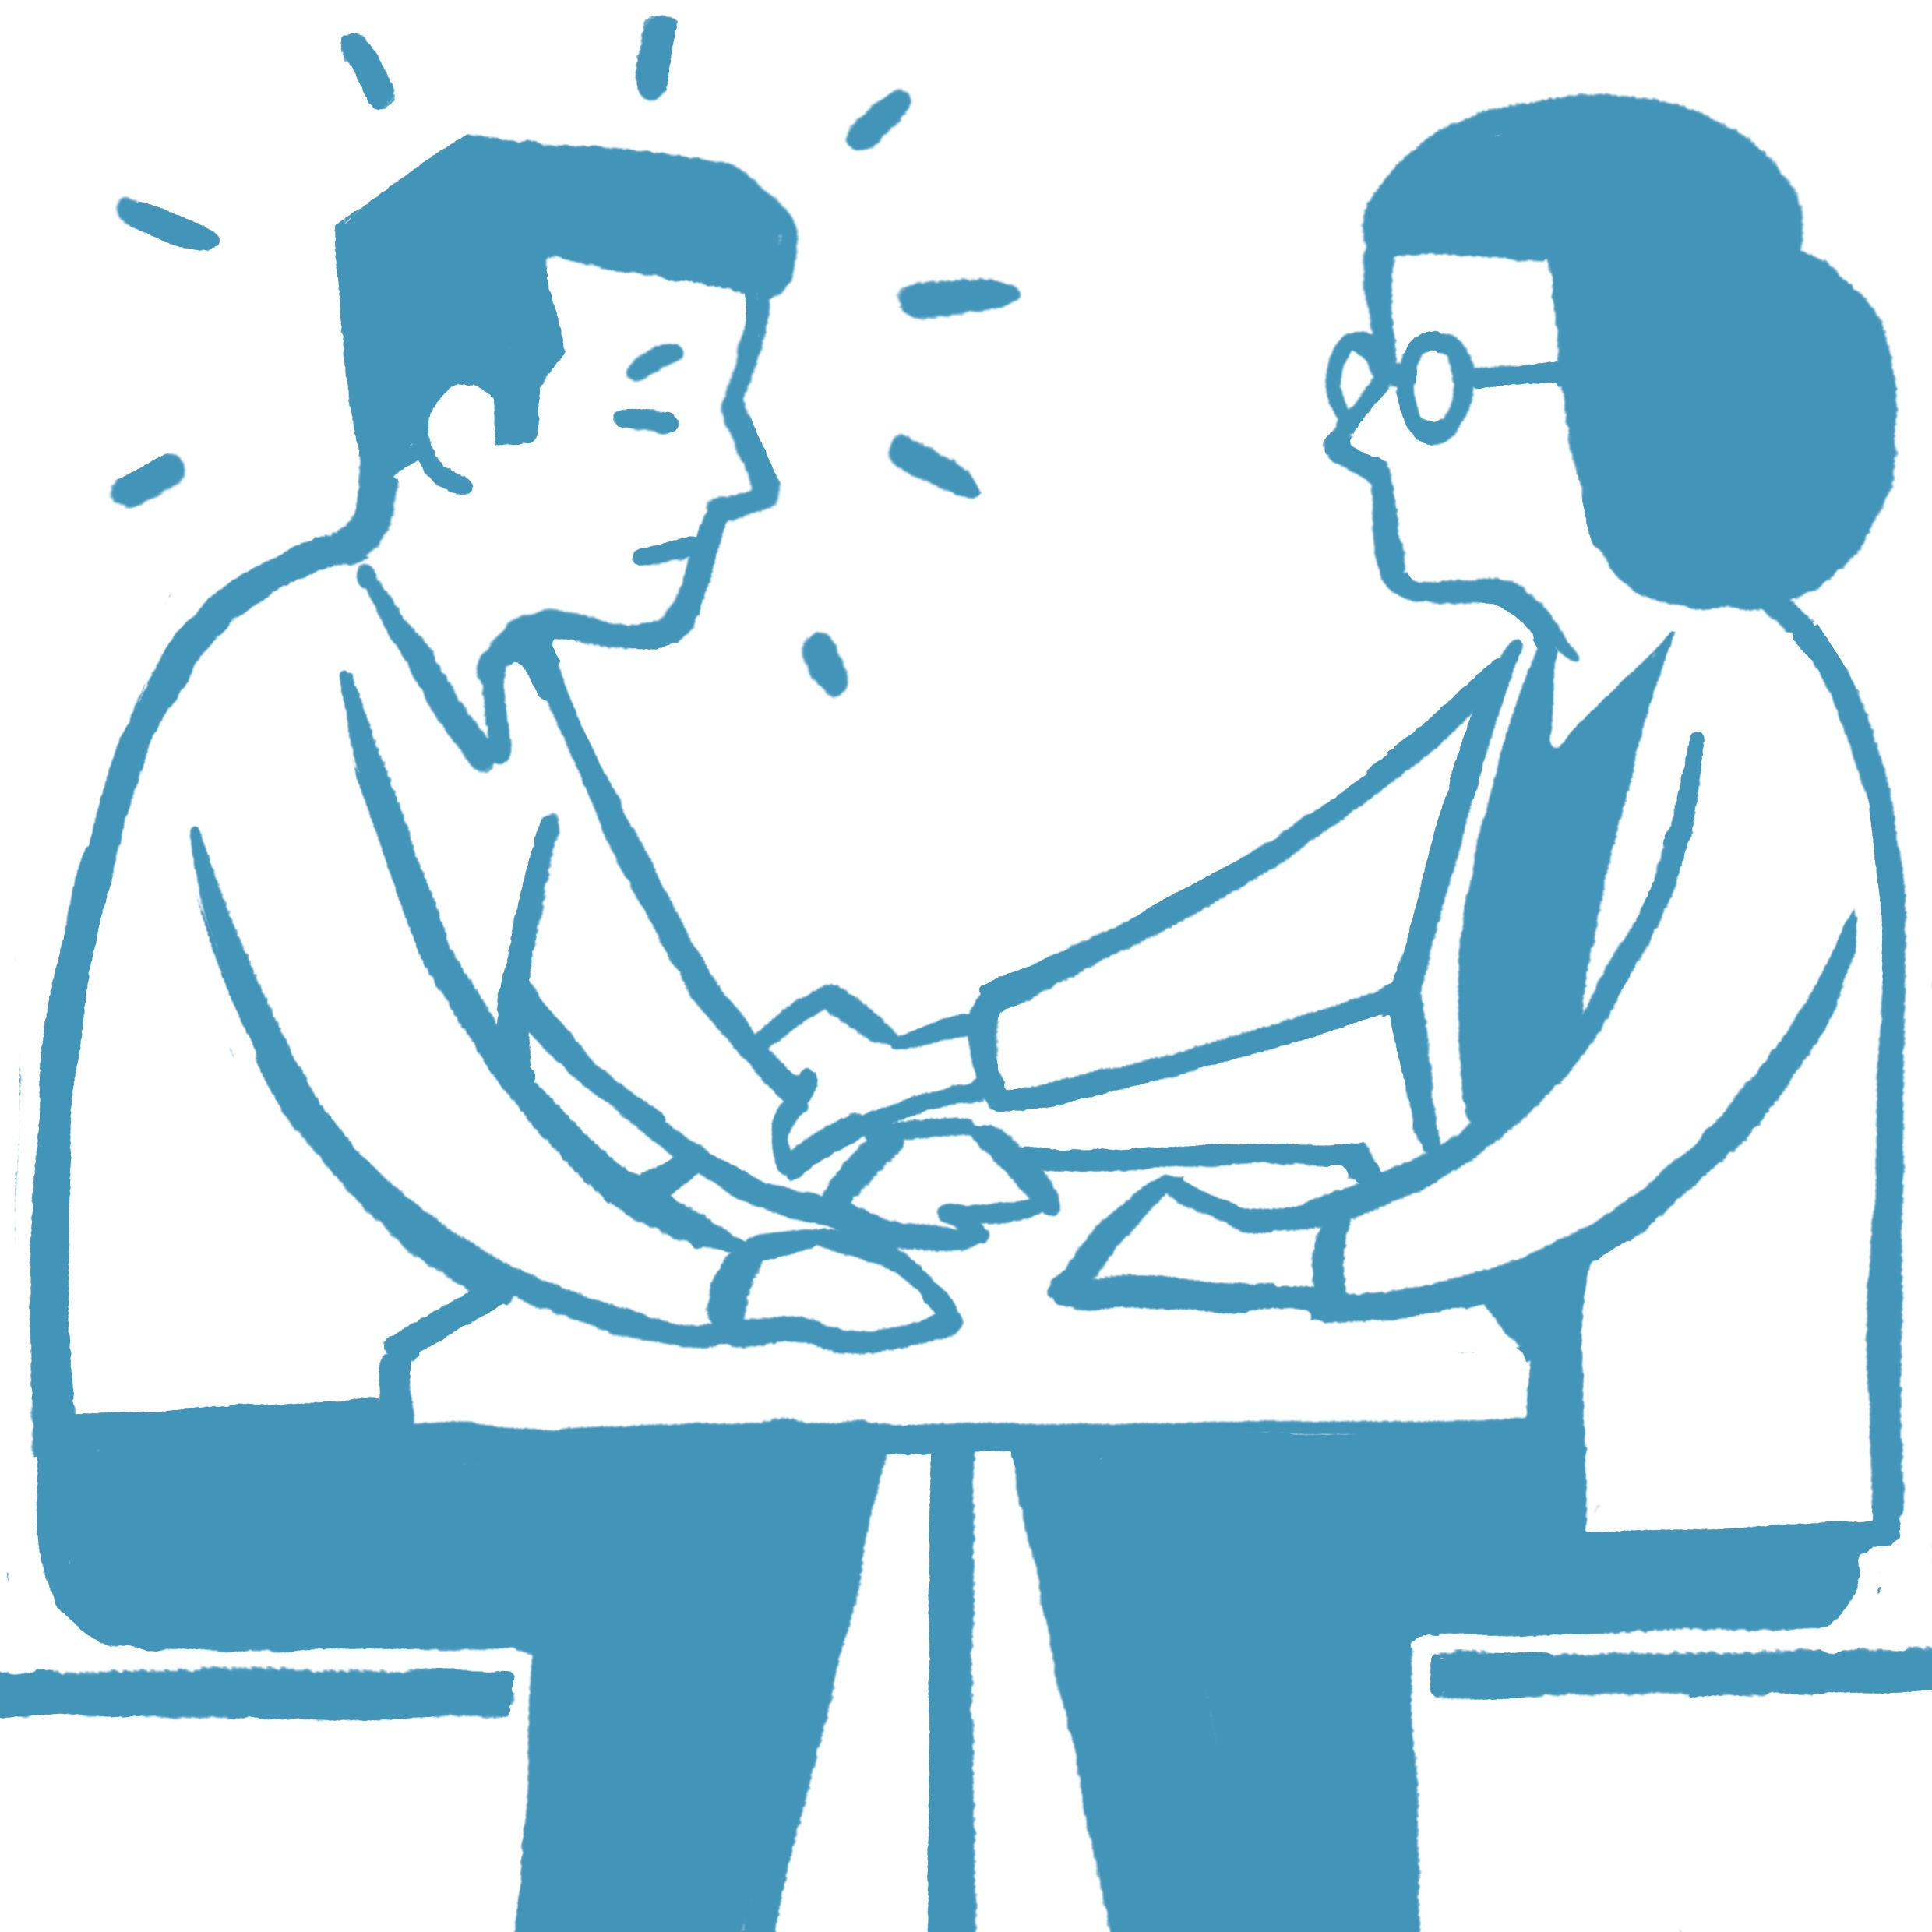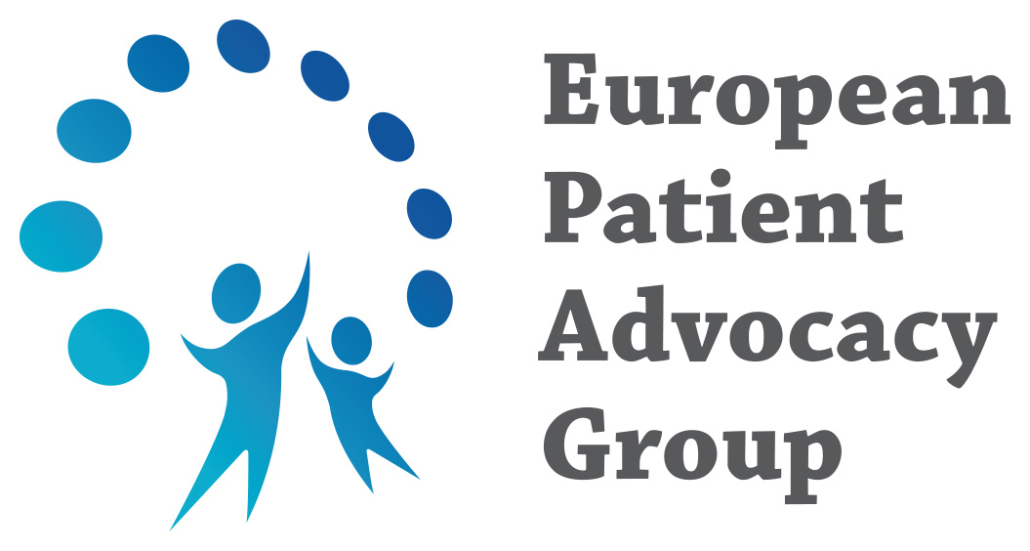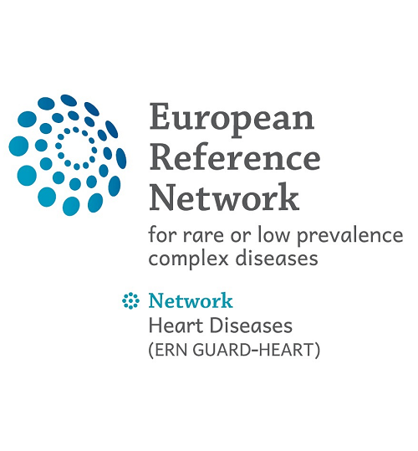

Understanding and processing all this information is a difficult journey that can bring many doubts, uncertainties, and fears. That is why it is essential not to face this situation alone and to seek support from specialized professionals.   
Psychologists and psychiatrists experienced in guiding people through traumatic grief, anxiety disorder and posttraumatic stress disorder can provide the necessary help. This support may be available through patient associations specializing in these rare heart diseases, in the cardiogenetic units of expert centers, or via personal appointments with a dedicated psychologist.

Support may also be available through support groups of patient associations dedicated to sudden cardiac death syndromes or specific cardiomyopathies or channelopathies, or through grief support groups. Sometimes speaking to others who have gone through the same situation helps a lot. It ensures you that there are others who have experienced the same and who were able to cope in the long run.  
Try to find the option that suits you best.

**Where do I find more information about inherited heart conditions?**

Website of your local expert centre  
[xxx](https://www.sjdhospitalbarcelona.org/es/)

Website of patient organisation or charity  
<https://guardheart.ern-net.eu/patients/epags/>

Website of ERN GUARD-Heart  
<https://guardheart.ern-net.eu/patients/disease-specific-brochures/>

**If you need support, don´t hesitate to contact:**

Address of your genetic counsellor  
[xxx](https://www.sjdhospitalbarcelona.org/es/especialistas/georgia-sarquella-brugada)

Address of your local expert centre  
[xxx](https://www.sjdhospitalbarcelona.org/es/)

Address of your local/national patient organisation  
[xxx](https://www.samsasociacion.com/)

Address of international patient organisation  
<https://sads.org/>

Address of Grief support groups  
[xxx](https://www.samsasociacion.com/paciente-experto)

Address of psychologists / psychotherapists  
[xxx](https://www.samsasociacion.com/asistencia-psicolgica)

Website of ERN GUARD-Heart  
<https://guardheart.ern-net.eu/>